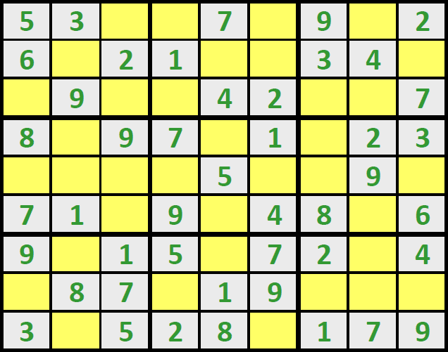

SUDOKU CHECKER 1.0

User’s Guide

City College Brighton and Hove

Radek Lochman

Access to HE Diploma: Computing

City College Brighton and Hove



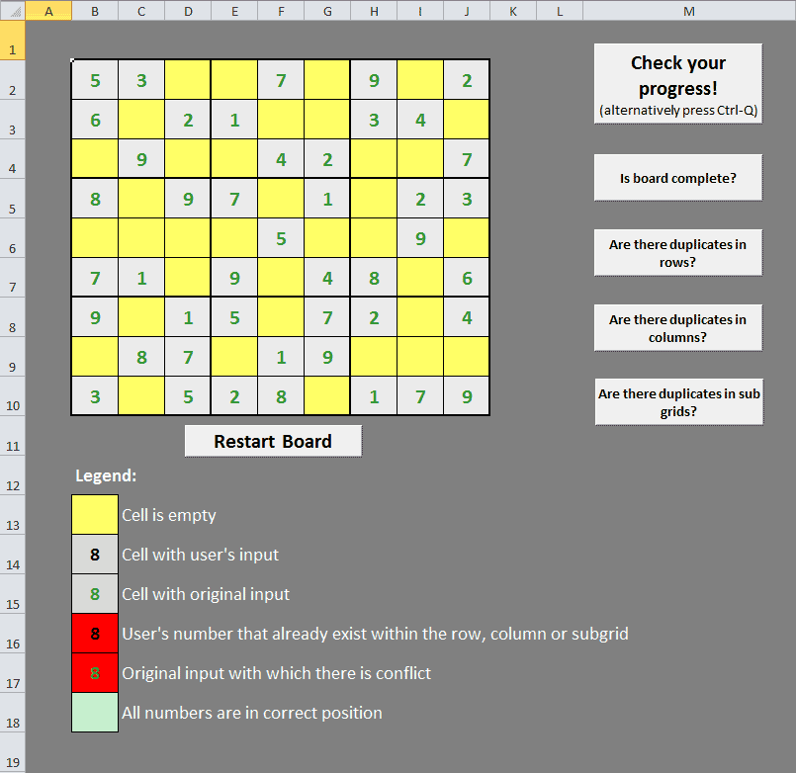SUDOKU CHECKER 1.0 is a program used to help user to solve given Sudoku puzzle.

**34567**

**1**

Figure - Sudoku Checker 1.0

**8**

**2**

# Parts of SC1 (as on Figure 1):

1. Sudoku board: This board contains Sudoku puzzle to be solved. If you are not sure about rules of Sudoku, you can find those on various websites (<http://www.sudoku.name/rules/en>)

Board starts with some numbers filled in already (grey boxes with green digits) and some empty fields (yellow boxes). For your convenience, all cells apart from empty (yellow) cells are locked for editing. So we prevent any accidental changes to original numbers or program itself. User can fill empty fields with any integer number between 1 and 9 included. Any other number or symbol will prompt an error message.

1. Restart Board button: This button will restore board to its original setting. After clicking on this button, it will prompt a question whether you are really sure about restoring board. If you click YES, it will restore board; if you click NO game will continue with user’s inputs.
2. Check your progress! button: Main button which executes all functions of this program. Once pressed it will check whole board for any errors. All empty fields will be marked yellow, filled fields which are valid will be marked grey and all fields which are not valid will be marked red. Always at least two numbers are marked red, those which are in collision with each other. Also a message will be shown which will say whether board have errors or not. In case that board is complete (all cells are filled without any errors) board will be marked green and message will be shown about completion of puzzle.
3. Is board complete? button: When this button is pressed, it will check whether board is complete or not. If board is complete, all cells will be marked grey and message will be shown that board is complete. **But it doesn’t mean that all numbers are in correct position.** If board is not complete, all empty fields will be marked yellow, all cells with numbers in will be marked grey. Message will be shown that board is not complete.
4. Are there duplicates in row? button: This button will check if there are any duplicate numbers within each row. If a duplicate is found, both (or more) numbers are highlighted red and message is shown. If no duplicates are found message is shown.
5. Are there duplicates in column? button: This button will check if there are any duplicate numbers within each column. If a duplicate is found, both (or more) numbers are highlighted red and message is shown. If no duplicates are found message is shown.
6. Are there duplicates in sub-grid? button: This button will check if there are any duplicate numbers within each sub-grid. If a duplicate is found, both (or more) numbers are highlighted red and message is shown. If no duplicates are found message is shown.
7. Legend: This part is to show and explain each colour output of program.

# Further details about program:

Program itself will not do anything until user presses a button. That means that if cell was previously found to contain a duplicate number, it will stay highlighted red until user press button again, even though that correct number has been inputted.

If user clicks on “restart board” button and chooses yes, there is no way how to retrieve previously inputted numbers, so please use that button with caution.

This program is a trial version and can be used only for predefined Sudoku puzzle. To unlock this program for use with any Sudoku puzzle, please upgrade to full paid version. (Only joking, just ask :o))

# And most important thing on the end:

**To use functions of this program, macros have to be enabled!!!**